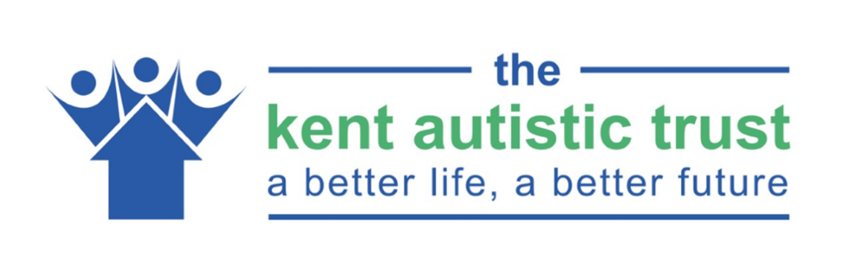

Covid-19 Information
Coronavirus Preparedness
​The Kent Autistic Trust is responding to advice given by Government and the World Health Organisation and has reviewed all our interactions, activities, meetings and other gatherings in order to reduce the risk of spreading the virus. So, before you set out for a meeting please check with the person if the meeting will be going ahead.
Hand sanitation and keeping distance is a requirement when visiting our office and all establishments. We may also ask you questions to assess risk and we may refuse entry to ensure the safety of the people we support and the staff we work with.

Interviews/Open Days/Inductions
If you have been tested positive for covid-19 or have been told to self-isolate in the last 14 days, and you will still be in self-isolation on the first day of your interview/open days/induction then please do not attend our premises. If this is the case, please contact Anna or Stephanie immediately on 01634 405168 or email humanresources@kentautistic.com.
​

